User Engagement

Tasks
1.
Pick any one app you use daily (Instagram, Zomato, Flipkart, etc.) and list 3 ways the app keeps you engaged (for example: notifications, daily streaks, personalized recommendations).
2.
Design a simple Instagram-style poll for a story: create a question and two answer options, then write a short plan for how you would collect and display the number of votes for each option.
3.
Write a sample push notification message that would encourage a user to return to a food delivery app like Swiggy or Zomato after 3 days of inactivity.<br><br><em><strong>Hint:</strong> Think about using offers, reminders, or new menu items to make it engaging.</em>
4.
Analyze the Flipkart app's product page and identify 2 engagement features (such as wishlist, ratings, or 'people also bought') and explain in 2-3 lines how each feature encourages users to spend more time on the app.
5.
Use ChatGPT or any AI tool to generate 3 creative ideas for increasing user engagement in a music streaming app like Spotify, and write them down in your own words.

(1). App Chosen: Instagram
No. | Feature | How It Keeps Users Engaged
1 | Push Notifications | Sends alerts for likes, comments, messages, and new posts to encourage users to open the app regularly.
2 | Personalized Recommendations | Recommends Reels, posts, and accounts based on the user's interests and activity.
3 | Stories and Reels | Provides short, entertaining content that keeps users scrolling and interacting for longer periods.

(2). 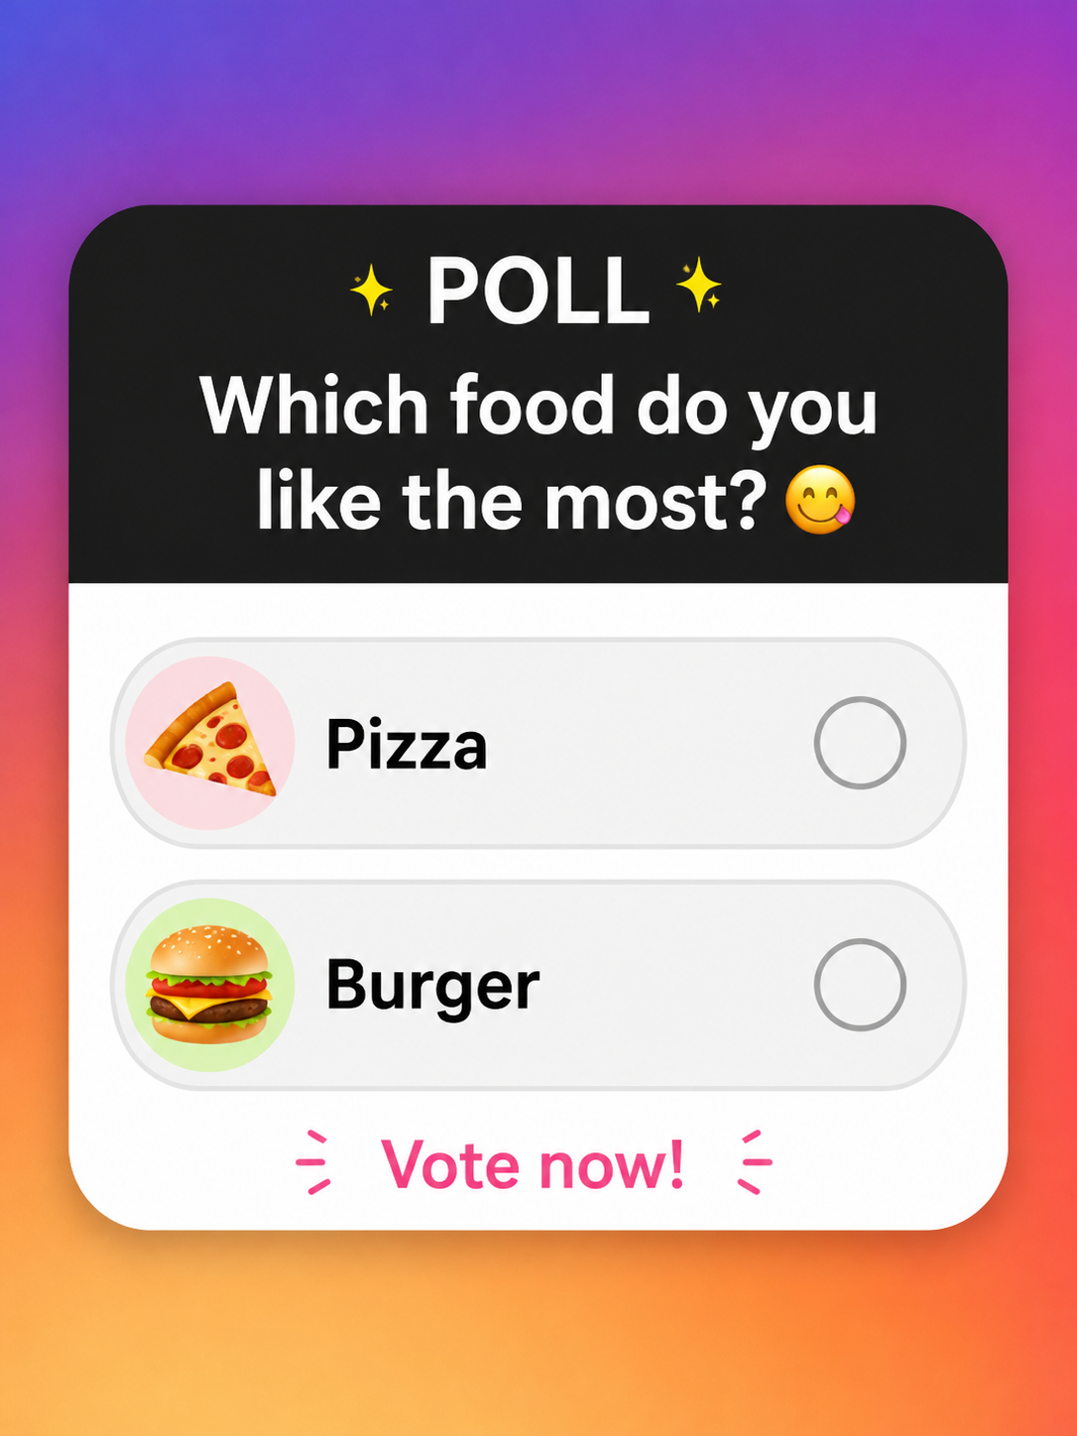

Item | Content
Poll Question | Which food do you like the most?
Option 1 | 🍕 Pizza
Option 2 | 🍔 Burger
(3). Sample Push Notification Message
🍔 We Miss You! Your favorite meals are waiting for you. Come back today and enjoy 20% OFF on your next order with code WELCOME20. Hurry, the offer ends soon—order now and satisfy your cravings!

(4). Flipkart Product Page – Engagement Features
Feature | How It Encourages User Engagement
Ratings & Reviews | Customers can read ratings and detailed reviews from other buyers before purchasing. This builds trust and encourages users to spend more time comparing products and making informed decisions.
People Also Bought / Similar Products | This section recommends related or frequently purchased items. It encourages users to explore more products, increasing browsing time and the chances of making additional purchases.

(5). 3 Creative Ideas to Increase User Engagement in a Music Streaming App
Idea | Description
1. Daily Music Challenge | Introduce a daily challenge where users listen to a specific genre or artist to earn badges, points, or rewards. This encourages users to return to the app every day.
2. Mood-Based Playlists | Use AI to create personalized playlists based on the user's current mood, such as Happy, Relaxing, Workout, or Study. This makes the listening experience more personal and enjoyable.
3. Friend Activity & Music Sharing | Allow users to see what their friends are listening to, share playlists, and create collaborative playlists together. This increases interaction and keeps users engaged for longer.

